Assignment module -1

1. What is software? What is software engineering?

* A Software is set of instruction and programs.
* That gives instruction to hardware what to do how to do.
* Computer did not understand human language Computer understand binary language.
* User gives instruction to software, software translate and gives output.
* Basically software is mediator between humans and hardware.
* To make better and quality software is software engineering.

1. Types of software.

🡺 There are many types of software but main is system software and application software.

🡺System software

🡪 The software that provides the basic functionality to operate a computer.

🡪 System software directly interacts with computer hardware.

🡺Operating software

🡪 Operating system is most basic system software.

🡪Without operating system computer cannot work.

🡺Programming software

🡪Programming software is a special type of computer software that can translate the source code into a binary language and gives output to users.

🡺Driver software

🡪 Driver software is a mediator between operating system and devise to work properly that particular device.

🡪Ex. Audio driver, Video driver, Printer driver etc

1. SDLC

🡺SDLC stands for software development life cycle that provides a model for the development and lifecycle management of an application or software.

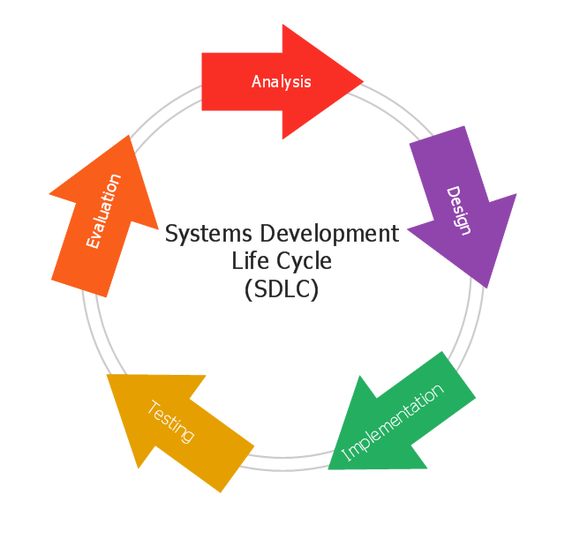 🡪SDLC is a process that development teams use to create awesome software.

* Requirement analysis :-

🡪The first step of the SDLC is the project planning where you are gathering information from analysis, market surveys and customer requirement.

* Design :-

🡪Make a design model as per customer needs.

* Implementation :-

🡪 In the implementation step, the team builds product through code.

* Testing :-

🡪 Test the final product that work properly and gives better user experience.

🡪In the testing step tester find bug and errors and resolve it before product is launch.

* Maintenance :-

🡪 In the maintenance stage make sure that product is work properly without bugs sometimes user may find bugs and defects in product resolve the problem.

🡪 Need to update product requirement etc.

1. DFD (DATA FLOW DIAGRAM)

🡺DFD stands for data flow diagram.

🡺By using DFD we can easily understand the overall functionality of system.

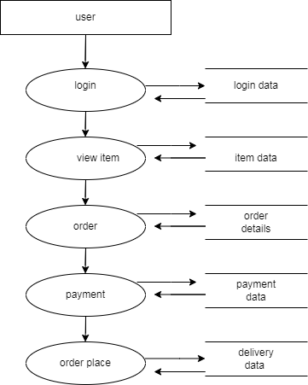

1. Flow chart :-

🡺 Flow chart is a graphical representation of how program process, run.

Addition between two no

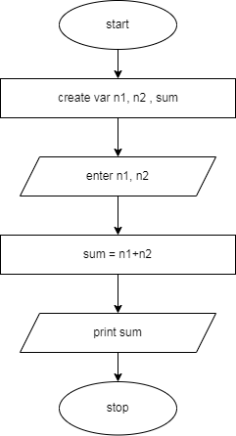

1. Use case diagram

